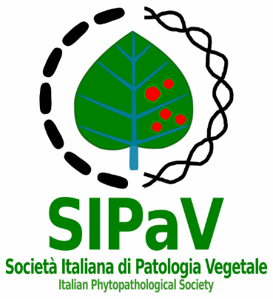
Società Italiana di Patologia Vegetale (SIPaV) Italian Phytopathological Society

“Giovanni Scaramuzzi” SIPaV Award 2022

The Italian Phytopathological Society (SIPaV), with the aim to promote the interest of young researchers in Plant Pathology, every year assigns an award to the best PhD thesis in the Plant Pathology, in honor of Prof. Giovanni Scaramuzzi.
A contribution of Euros 1,000 (one thousand) will be assigned, including Society gadgets, a certificate issued by SIPaV and one year free membership to the Society, including access to the Journal of Plant Pathology (JPP).
Participation is reserved to PhDs who have received their degree in the period between May 1, 2021 and May 31, 2022 and not be more than 35 years old at December 31, 2021.
The Award application, addressed to the SIPaV President must be sent by e-mail at segreteria@sipav.org by July 01, 2022 and must be accompanied by the following attachments:
1. A copy of the doctoral thesis in PDF format.
2. A self-declaration of the date of birth and professional status (SIPaV member or not, employed, not employed) of the candidate. The signed declaration must be scanned and sent in PDF format.
3. A concise curriculum vitae, indicating the achievement date of the PhD degree.
4. The e-mail address for Award communications, the telephone number and the IBAN code for the transfer in case of Award winning.
The SIPaV secretariat will communicate via e-mail the acceptance of the application.
The data transmitted by the candidates with the application form, according to art. 10 of L. 21/12/96 n. 675, will be treated only for the competition procedure management.
In case of Award winning, the candidate will personally present the work, during the XXVII SIPaV Congress, which will take place in Palermo from September 21 to September 23, 2022, and to submit it in an “abstract” form, according to the rules of the Journal of Plant Pathology, for publication.
The Committee will consist in SIPaV President and Vice-President and a Delegate of the Scientific Committee of the XXVII SIPaV Congress. The Committee judgment will end by July 22, 2022.
The Award assignment will take place only according by the Examining Committee.

The SIPaV President
Prof. Matteo Lorito
Inserire firma del magnifico Lorito

c/o Dipartimento di Agraria
Università degli studi di Napoli Federico II
Via Università 100, 80055, Portici (NA)
Tel. 081 2539001; 081 2532253
e-mail: presidente@sipav.org, segreteria@sipav.org
c.f. 92030110370

