

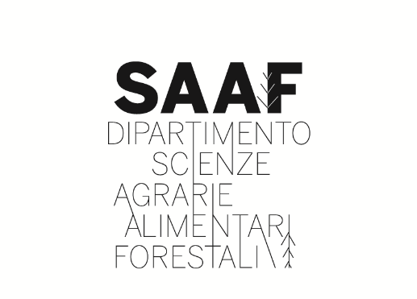

ACCOMODATION

The hotel reservation must be made directly by each participant by sending an e-mail to the Hotel/B&B. Because September is still tourist season in Sicily, it is advisable to book hotels as soon as possible. Around the Campus University there are many Hotels and B&B, some suggestions can be found in the list below:

Hotel

Hotel NH Palermo - 4 star hotel
Foro Italico, 90133, Palermo
www.nh-hotels.it/hotel/nh-palermo
Ph. +39 091 6165090

Hotel Athenaeum - 3 star hotel
Via Luigi Giannettino, 4, 90128 Palermo
www.albergoathenaeum.it
Ph. +39 091 6523529

Hotel Villa Archirafi - 3 star hotel
Via Lincoln, 30, 90123 Palermo
www.villaarchirafi.com
Ph. +39 091 6168827

Hotel Palermo Quattro Canti - 3 star hotel
Via Vittorio Emanuele, 291, 90133 Palermo
palermo@hotelbb.com
Ph. +39 091 332082

B&B

L’Hôtellerie Easy Suites
Foro Italico Umberto I, 13, 90133 Palermo
www.lhotellerie.it
Ph. +39 339 5898058

BB La Meridina
Corso Pietro Pisani, 294, 90129 Palermo
www.lameridianarooms.com
Ph. +39 327 8218954

Reale Orleans
Via Giovanni Dotto,12 90129 Palermo
casarealeorleans@gmail.com
Ph. +39 328 0693181

